**SOTERIA PROJECT**

# DEVELOPMENT OF A BLACK BOX SYSTEM FOR VUILNERABLE SUBJECTS ON THE ROAD

## FIRST UPDATE ON THE PROGRESS

**AUTHORS**: HAIDER ALI KHAN AND ADNAN AL SAID

**DATE:** 23/02/2024

# TABLE OF CONTENT

Contents

DEVELOPMENT OF A BLACK BOX SYSTEM FOR VUILNERABLE SUBJECTS ON THE ROAD 1

FIRST UPDATE ON THE PROGRESS 1

TABLE OF CONTENT 2

INITIAL SETUP 3

Aim of the project. 3

Type of data collected. 3

Users condition 3

Environmental condition 3

Vehicle condition 3

First solution. 3

Hardware received. 4

SYSTEM IMPLEMENTATION 6

Setup of the raspberry pi. 6

Air sensor integration. 6

Pulse sensor integration. 8

Lidar sensor integration. 9

CONCLUSION 11

# INITIAL SETUP

## Aim of the project.

The project aim was presented by the Dr Suresh Renukappa from University of Wolverhampton. This consists of developing a device to monitor and collect date surrounding vulnerable users on the road. The data collected from multiple users across the country will be used to find the causes of the incidents.

The device will be developed primarily for cyclist and will be mounted on aa bicycle via custom mount.

## Type of data collected.

The device must retrieve information from the following categories: the user’s condition, the environmental condition and the condition of the vehicle.

### Users condition

The data collected from the user will display their mental and/or physical conditions. This could be the heartbeat, body temperature, focus level etc.

### Environmental condition

This type of data will reflect the scenario and the environmental condition the user was exposed to. This could be the temperature, presence of harmful gases, quality of air, ambient light noise etc.

### Vehicle condition

This type of information is essential to determine the vehicle’s condition. This could be the distance of the obstacles around, the speed and inclination, vibrations to measure shocks and mechanical stress levels etc.

## First solution.

The solution that was initially adopted by the university lecturers was to use the Raspberry Pi as the main microcontroller to collect and elaborate all the raw data from various sensor. The sensors adopted were a camera, accelerometer and gyroscope, temperature sensor, GPS and few other.

### Hardware received.

The first hardware received are:

* Raspberry pi 4.
* SD card 32GB 10th gen.
* Ultrasonic distance sensors.
* Gyroscope and Accelerometer.
* GPS module.
* Power bank.
* Barometer.

At that stage it was decided to collect one type of data form the three categories due to the tight deadline:

* Pulse sensor for the user condition.
* Air quality monitoring for the environmental condition.
* Obstacle detection for the vehicle condition.

Since those type of sensor was not present, research was conducted to achieve the best sensor quality in the shortest time possible. Therefore, the following hardware was requested:

* Amped analogue pulse sensor.
* 360 LIDAR sensor.
* Air quality sensor.

# SYSTEM IMPLEMENTATION

### Setup of the raspberry pi.

Due to the lack of an external monitor, keyboard, and mouse, it was decided to configure the raspberry pi 4 as a headless station. To do so it was vital to enable the correct option for remote access during the firmware flashing. Choosing the firmware, it is a critical part that affects the system integration, at the beginning the main and recommended OS was selected. However, this might be changed in the future to select an OS with more compatibility for hardware and software integration for various sensors.

While using the pi as a headless module the following issue were encountered: overheating of the board, latency, and lag of the connection between the board and the computer. The solutions to those problems were quite simple which involved using a standard pi setup with monitor, keyboard and mouse to compensate the lag and delays of the system and to install heatsinks on the sensitive ICs of the pi.

### Air sensor integration.

The BME688 air quality sensor, equipped with AI-enhanced gas scanning capabilities, accurately measures temperature, pressure, humidity, and detects volatile compounds like VOCs and VSCs. Integrated with the Breakout Garden system and Raspberry Pi, it enables comprehensive environmental monitoring and analysis, facilitating ventilation assessment and project development. Its compatibility with various microcontrollers and HATs ensures versatile integration for diverse applications.

It uses the I2C protocol, and the data was successfully retrieved from the sensor using a Python script. It was noticed that even if the connection is successful, the data read is not stable and accurate as it fluctuates or it stops being updated.

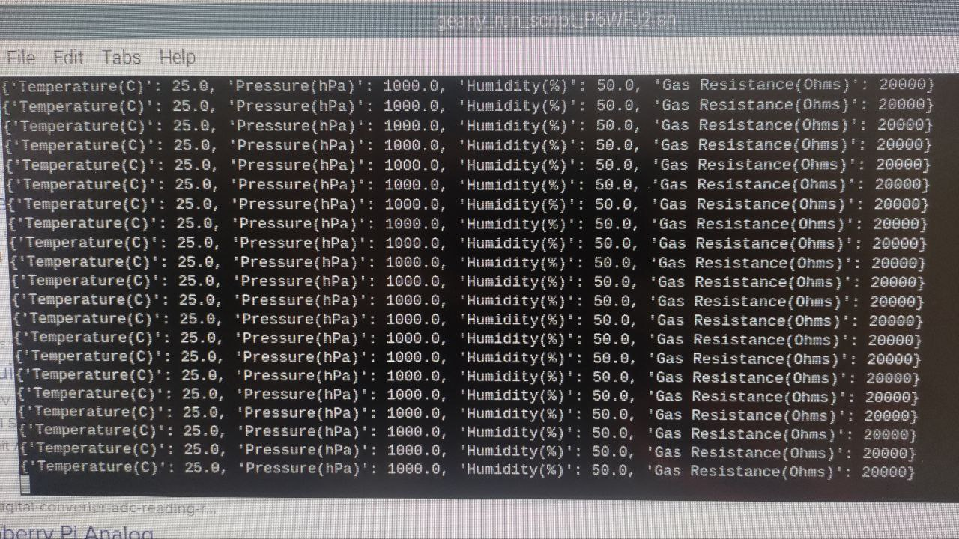

### Pulse sensor integration.

The Pulse Sensor Amped, an upgraded version of the original Pulse Sensor, offers a plug-and-play solution for incorporating real-time heart-rate data into projects for Arduino and its compatibles, appealing to students, artists, athletes, makers, and developers. With added amplification and noise cancellation circuitry, it provides faster and more reliable pulse readings, compatible with both 3V and 5V Arduinos. Additionally, enhancements to the accompanying Processing visualization software and Arduino code further improve usability and performance.

Since the pi does not have a built-in ADC, an Arduino Uno was connected to the pi to utilise one of the analogue input pins. The hardware and software integration were successful as the data retrieved was matching the heartbeat of the user.

It is planned to remove the Arduino Uno and replace it with a standalone ADC chip to simplify the cost and complexity of the hardware.

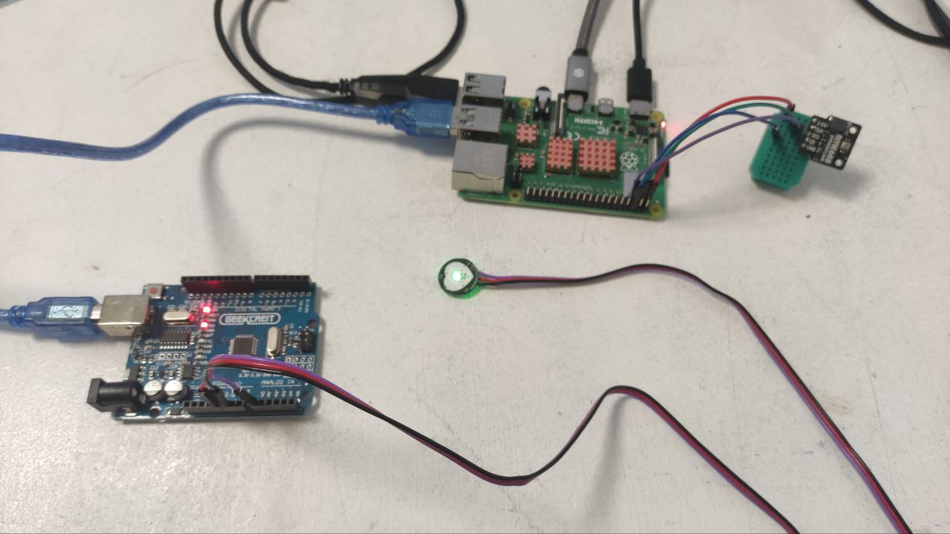

### Lidar sensor integration.

Lidar (Light Detection and Ranging) employs laser targeting and time measurement to determine distances by measuring the reflected light from objects or surfaces. This Lidar model rotates clockwise, scanning the environment with a 360° omnidirectional laser, using triangulation technology to achieve rapid distance measurements of up to 23,000 times per second. The LD14P variant extends sensing range to 8 meters, enhancing its utility for mapping and navigation tasks. Featuring start/stop control, glass wall detection, robust ambient light tolerance, and a lightweight design, this Lidar kit offers versatile functionality and easy integration into various projects.

This has been one of the hardest parts of the project due to the lack of documentation available online and the many incompatibilities of the software used by the LIDAR with the OS of raspberry. It was decided to install ROS to build an environment where the LIDAR would map the shape of surroundings using the angle and distance of the data retrieved.

The Jupiter IDE was installed for this scope and the data was retrieved via USB since the UART protocol can be converted to serial with a TTL converted provided by the manufacturer.

# CONCLUSION

The speed of the progress of the project match with the expected speed. There have been many complications so far, therefore it will be considered to change the main microcontroller and the type of sensors used. This will be done by keeping in focus the main objective of the project and the main type of data requested.